To improve the quality of teaching and learning process, the department has AI&DS enabled laboratories.

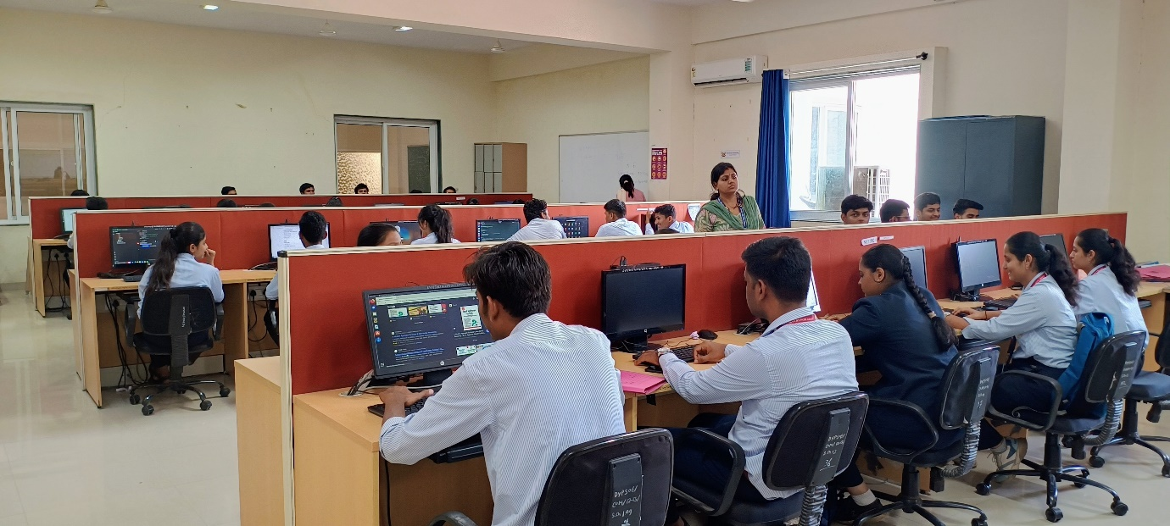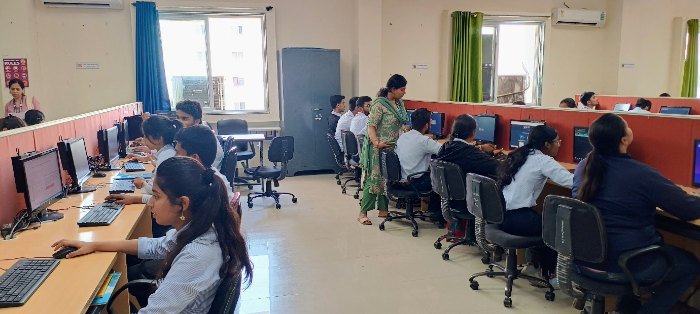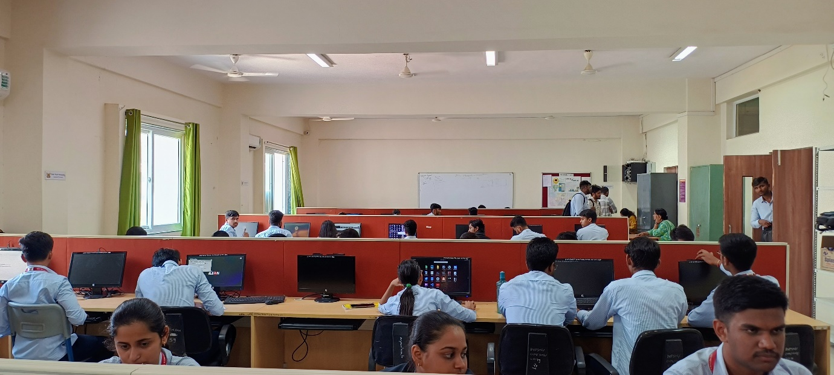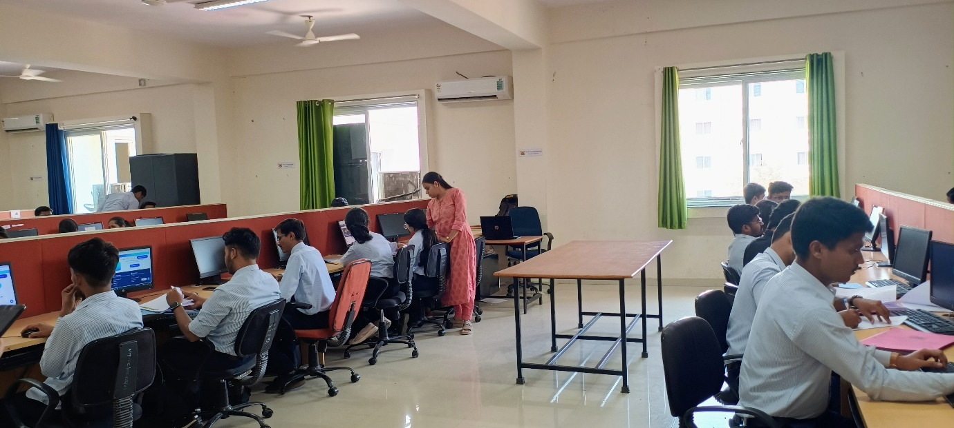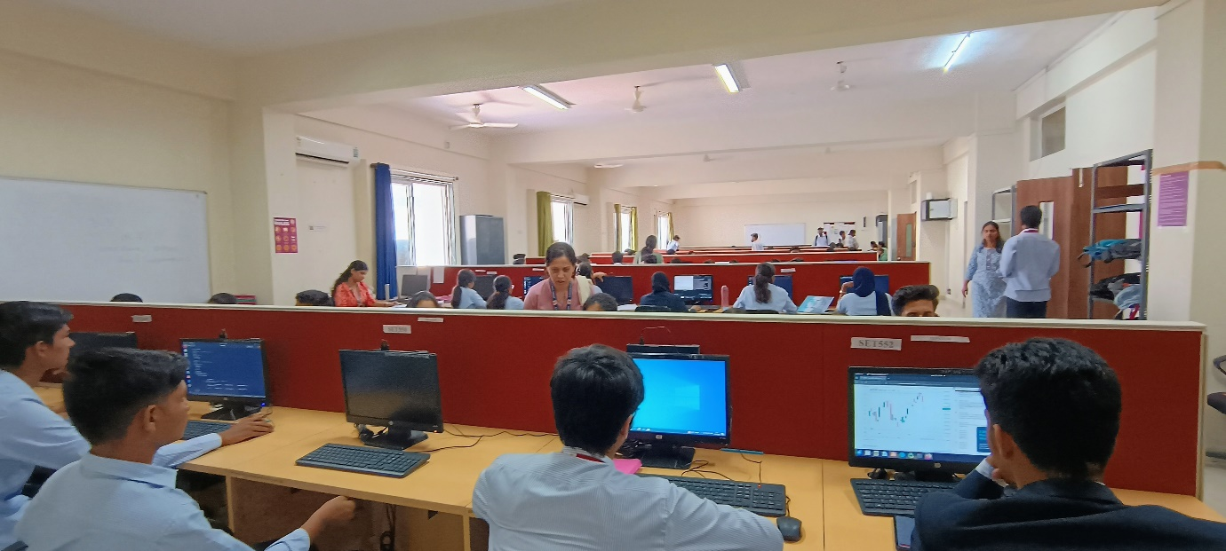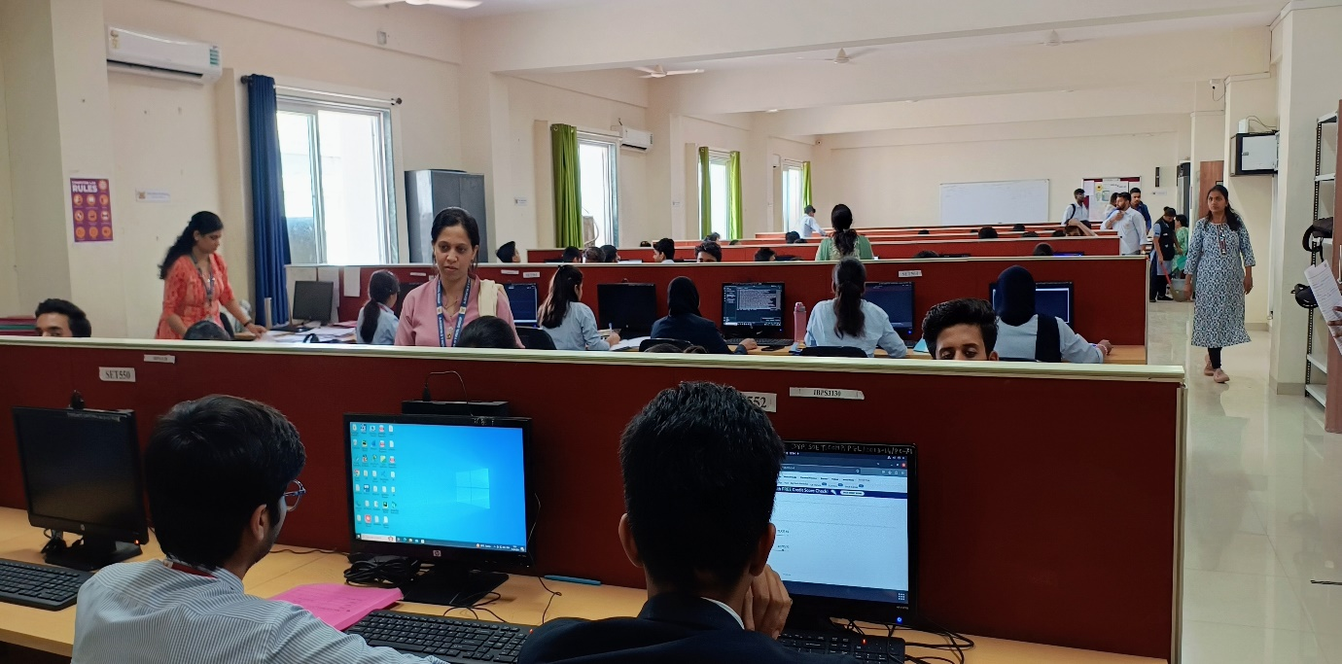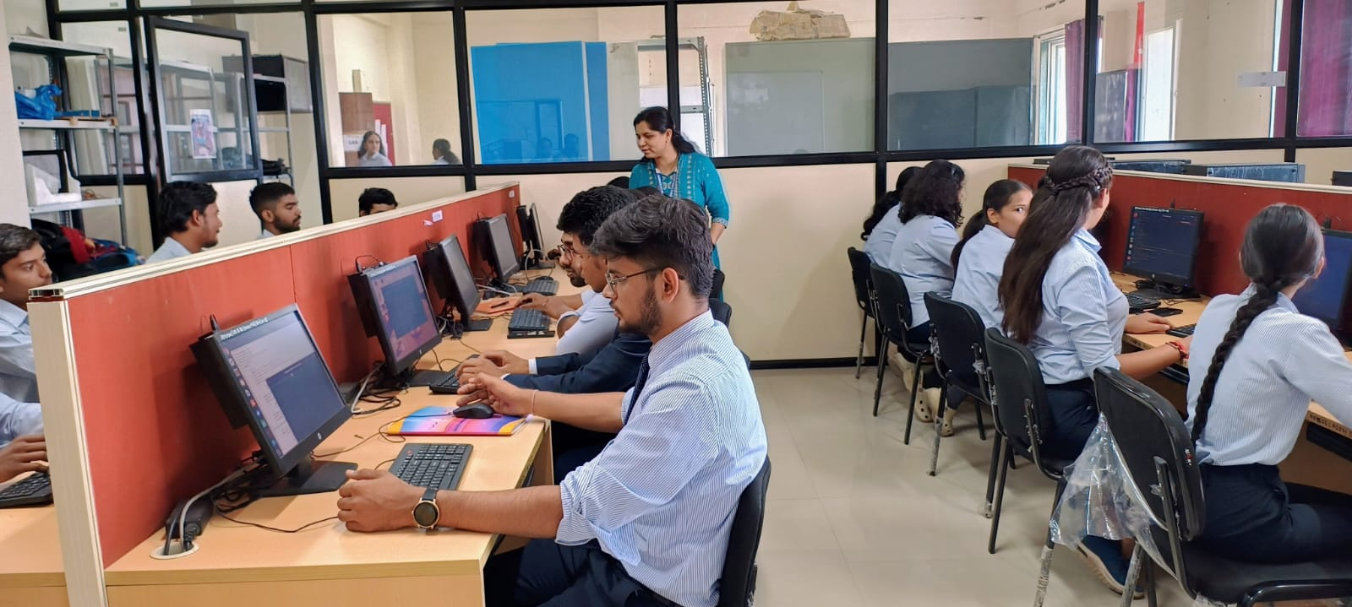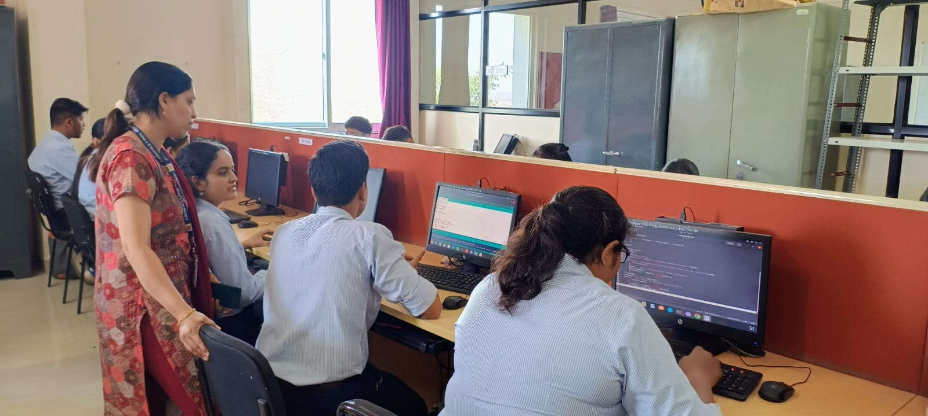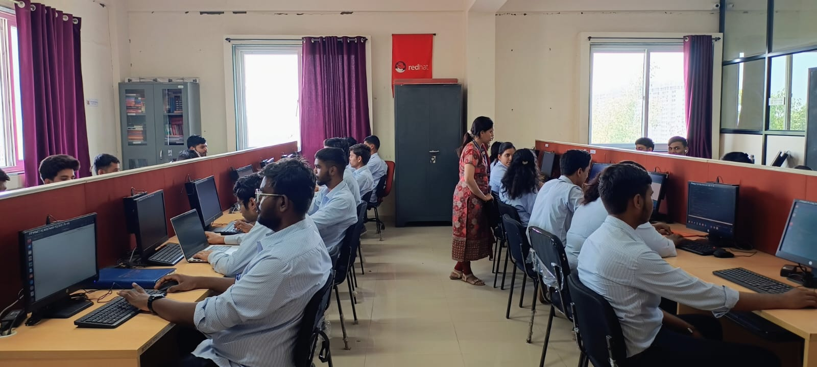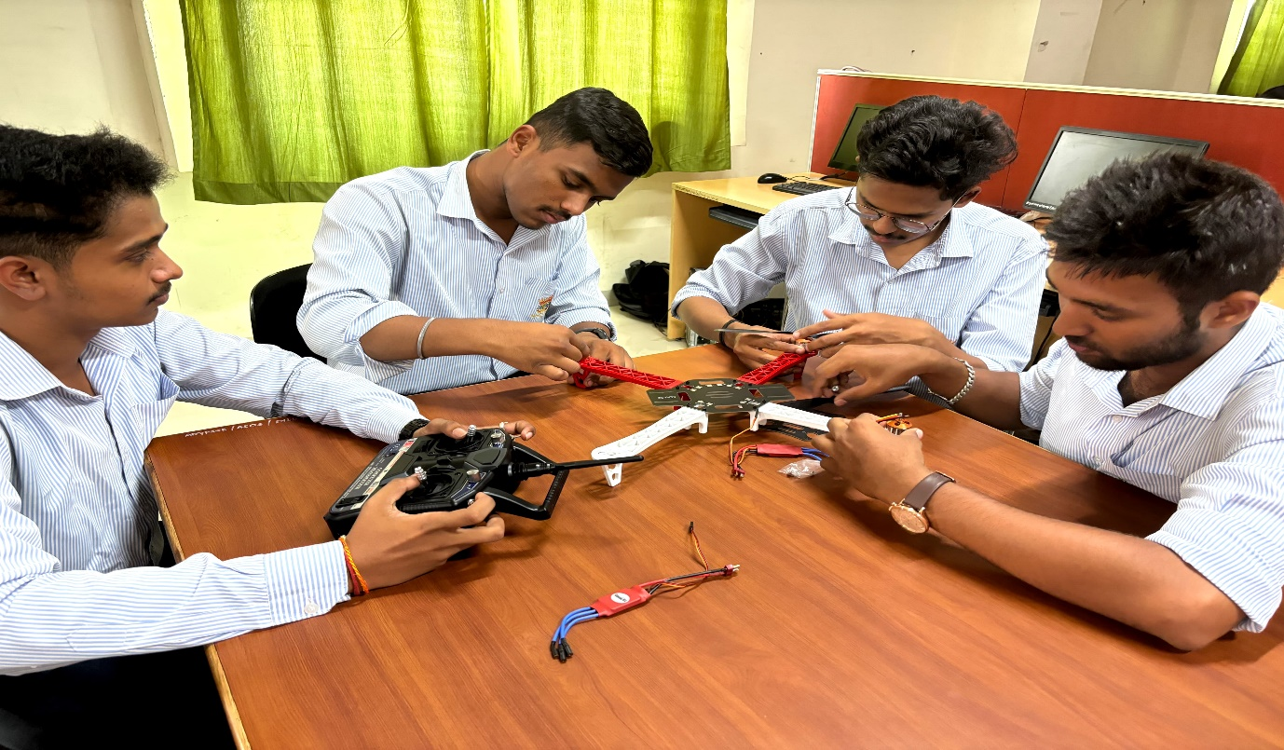

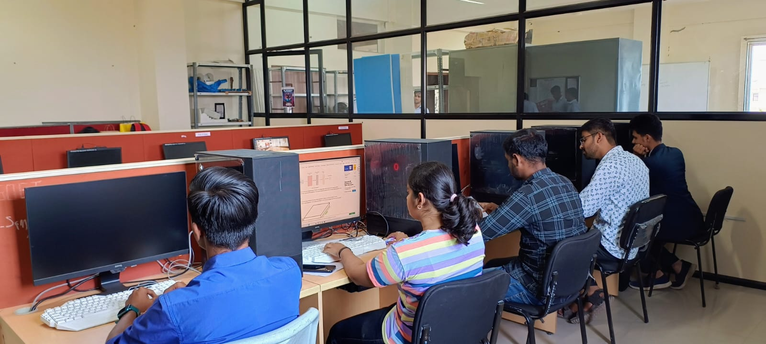

**Laboratories:**

|  |  |
| --- | --- |
| **Sr. No.** | **Name of the Laboratory** |
| 1. | Project Lab |
| 2. | Data Structures Lab |
| 3. | Internet of Things Lab |
| 4. | Artificial Intelligence Lab |
| 5. | Programming Lab |
| 6. | Machine Learning Lab |

|  |  |  |
| --- | --- | --- |
| **Sr. No.** | **Equipment** | **Specifications** |
| 1. | Computer | Windows 10 Pro, 22H2 Version  Intel(R) Core (TM) i7-6700TE CPU @ 2.40GHz 2.40 GHz, 8.00 GB (7.88 GB usable) 64-bit operating system, x64-based processor |
| 2 | Printer | Canon, LBP 2900B, Printer |
| 3 | Switch | 24 Port Switch 24 x 100 mbps +2 x 1000 Mbps |